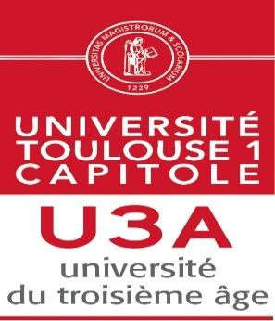
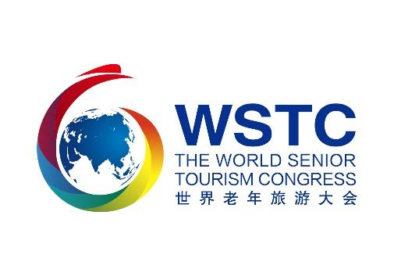

ENROLMENT FORM

First name
Last name
Nationality
City / Country
E-Mail address
Telephone
University of Third Age

I register for the contest in the category (several choices possible):

Poetry: yes / no
Drawing / painting: yes / no

Creativity yes / no

Singing yes / no

Sports photo yes / no

Form to be returned before August 15th

For English, French, Spanish, Italian, Portugese to AIUTA Office
secretariat.aiuta@gmail.com Tel 33 561633637

For Chinese please contact WSTC Office wstcchina@163.com Tel 0535-6952096

