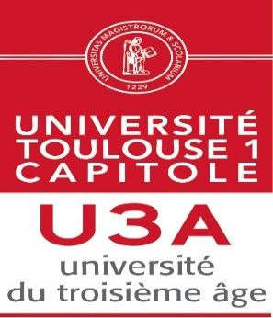
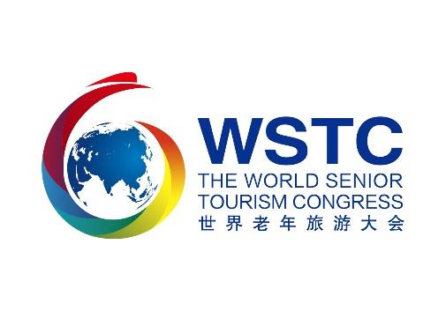

ENROLMENT FORM

First name
Last name
Nationality
Country / city
Phone number
Mail address
University of the Third Age

I register for the contest in the category (several choices possible):

Poetry: yes / no
Drawing / painting: yes / no

Creativity yes / no

Singing yes / no

Sports photo yes / no

Form to be returned before 2020, August 15
For English, French, Italian, Portuguese and Spanish please contact AIUTA office secretariat.aiuta@gmail.com +33561633637
For Chinese, please contact the WSTC office wstcchina@163.com 0535-6952096

